Comparative Sequence Analysis of BRCA1 and BRCA2 Using NCBI RefSeq Data with GC Content, ORF, and Statistical Analysis

INTRODUCTION

BRCA1 and BRCA2 are likely the best-known cancer genes. They are probably well known to most people, outside the context of biology, in terms of breast cancer risk. Both genes are tumor suppressors, and people with inherited mutations are more likely to develop breast and ovarian cancer. This has been firmly established and well documented. The comparative sequence-level characterization using fundamental computational analyses remains useful. The two genes, BRCA1 and BRCA2, are located on chromosomes 17 and 13, respectively. The overall protein structure of BRCA1 is fairly unstructured, but it does have two well-defined structured domains: a RING domain near the N-terminus, which forms a protein complex with another protein, BARD1, and is an enzyme (an E3 ubiquitin ligase); and a BRCT domain near the C-terminus that binds to phosphorylated proteins, which is typical of general DNA repair proteins. BRCA2 is structurally different. It is composed of eight repeated segments (BRC repeats) that can tightly bind to a protein known as RAD51 and also has a C-terminal DNA-binding domain. The difference in structure correlates with a difference in role and function. BRCA1 is involved earlier in the process of repairing damaged DNA, removing the ends of DNA and determining which pathway the cell will take for repair, whereas BRCA2 has a more specific function, loading RAD51 onto the single-stranded DNA to find and pair it with another single-stranded piece of DNA elsewhere in the genome. The mutations are in both genes and increase breast and ovarian cancer risk, but the two proteins are not redundant; they are complementary and part of a single process.
Since BRCA1 and BRCA2 are very different in their functional and structural properties, it was considered that there would be some corresponding level of fundamental difference, such as raw sequence composition. Another feature that occurs frequently in genomics is GC Content, the latter for several practical reasons. Double-stranded DNA, which is formed by regions with high GC content, is more stable and can influence the tightness of DNA packing and the accessibility of DNA-working machinery. The GC content is also non-uniform throughout the genome and is related to gene density and expression, and can affect the susceptibility of a region to specific types of mutation and/or recombination. If you want to characterize a gene computationally, but not just describe it in words, then a good first step is to look at the GC content of the sequence, rather than just the average GC content.

It's not a novel idea either as it's just a typical first approach to making a comparative genomic study by comparing two or more sequences (genes, transcripts, genomes, etc.) for similarities or differences before going on to more advanced comparisons. This type of comparison usually takes place across species to determine how conserved a gene is across evolutionary history, but there's no reason the same basic techniques can't be applied within a single species, comparing two different genes that are known to be functionally related, like BRCA1 and BRCA2 are here. That is the direction that this project goes in.

This project attempts to solve some of these foundational computational problems. Human reference mRNA transcripts for BRCA1 (NCBI accession NM_007294.4) and BRCA2 (NM_000059.4) are used, both of which are the MANE Select transcripts, meaning they're the standard reference version that NCBI and Ensembl agree on for these genes. I analysed the nucleotide composition, GC skew, AT skew, open reading frames and also simulated some point mutations to observe the change in the resulting protein. In addition, I performed a statistical significance test in R to determine if the difference in GC content between the two genes was significant or noise.

METHODOLOGY

Overview of the Pipeline
This project was built using a three-part pipeline: Linux, Python, and R together, and each one had a specific job.

LINUX was used for extracting the sequence data from NCBI. I did this via the terminal instead of manually downloading the files from the website, mainly so the exact steps are documented, and someone else could re-run the same commands and get the same files.
Python, run through Google Colab, did most of the actual analysis, including parsing the sequences, calculating composition and skew, finding ORFs, as well as conducting the SNP simulation. I have used Biopython because it's the standard library for handling sequence data correctly rather than treating the FASTA file as a plain text string.
R came in at the end specifically for the statistical test and comparison plot. I used it because R's built-in ‘t.test()’ function and the ‘ggplot2’ package are what most people in genomics actually using for this sort of comparison, and it is easier to switch over for that part rather than trying to force everything through Python.

Data Acquisition, Composition, and Sliding-Window Analysis

The Homo sapiens reference sequences of BRCA1 (NM_007294.4) and BRCA2 (NM_000059.4) were directly downloaded from NCBI using ‘curl’, through their E-utilities API, instead of downloading manually:
curl "https://eutils.ncbi.nlm.nih.gov/entrez/eutils/efetch.fcgi?db=nucleotide&id=NM_007294.4&rettype=fasta&retmode=text" -o data/fasta/brca1.fasta
curl "https://eutils.ncbi.nlm.nih.gov/entrez/eutils/efetch.fcgi?db=nucleotide&id=NM_000059.4&rettype=fasta&retmode=text" -o data/fasta/brca2.fasta

Both are the MANE Select versions for their respective genes, the "default" version that NCBI and Ensembl both agree on. Once downloaded, I parsed both FASTA files using Biopython’s ‘SeqIO.read()’ function to pull out the sequence ID, description, and the actual nucleotide sequence for each gene.
I calculated the number of times each base A, T, G and C was seen in each gene, and the percentage of the total sequence length that each base occupied, as well as the overall GC percentage. This was primarily a beginning, a simple description of each gene prior to examining the changes in composition along the sequence.

A single GC percentage for the entire gene doesn't give much indication of whether some segments of the gene are more GC rich than other segments, so I used a 100 Sliding window approach in which each new window is offset 50 bp from the previous window and hence overlap by half: I computed the GC content and also the GC skew ‘(G-C)/(G+C)’ and AT skew ‘(A-T)/(A+T)’ of each window, which are commonly used to detect imbalance in composition of a sequence.

ORF Detection and SNP Mutation Simulation

I ran each sequence in all three reading frames for ORFs, looking for the start codon (ATG) and then a stop codon (TAA, TAG, or TGA) later in the same frame. I only retained ORFs longer than 100 bp as matches shorter than that are more likely to be random and not biologically significant.

To understand how a single mutation might affect the resulting protein, I simulated 20 random point mutations in each gene's coding sequence (again with a fixed random seed to ensure repeatable results if anyone runs the code again). I simulated each mutation, found the codon that it was located in, replaced the one base of each simulated mutation, and translated them both into amino acids with Biopython's translate function. If the amino acid stayed the same, it was labeled synonymous; if it was different, non-synonymous.

Statistical Testing and Visualization

By importing the window-level GC content values for both genes into R, a Welch two-sample t-test was performed to observe whether the average GC content difference between the two genes was "significant" or merely random. Later, a boxplot was created with ggplot2 to visualize the same comparison.

Tools and Environment summary

Component | Tool / Library | Purpose
Data retrieval | Linux, curl, NCBI E-utilities | Reproducible FASTA download
Sequence parsing | Python, Biopython (SeqIO) | Reading and structuring sequence data
Composition/skew analysis | Python, custom functions | Nucleotide %, GC content, GC/AT skew
ORF detection | Python, custom reading-frame scan | Identifying coding regions
Mutation simulation | Python, Biopython (Seq.translate) | Simulating and classifying SNPs
Statistical testing | R, t.test() | Comparing GC content distributions
Visualization | Python (matplotlib), R (ggplot2) | Figures for Results section

RESULTS

The mRNA reference sequences used for all analyses were for the human species (Homo sapiens) and were both BRCA1 (NCBI accession NM_007294.4) and BRCA2 (NM_000059.4). Throughout this section, "BRCA1" and "BRCA2" refer specifically to these human reference sequences.

Nucleotide Composition
Table 1 summarizes the nucleotide composition of BRCA1 and BRCA2 of Homo sapiens
INDEX | BRCA1 | BRCA2
Length (bp) | 7088 | 11954
A (%) | 33.41 | 35.64
T (%) | 24.82 | 28.18
G (%) | 22.36 | 18.55
C (%) | 19.41 | 17.63
GC (%) | 41.77 | 36.18
AT (%) | 58.23 | 63.82

Table 1: Nucleotide composition of BRCA1 and BRCA2
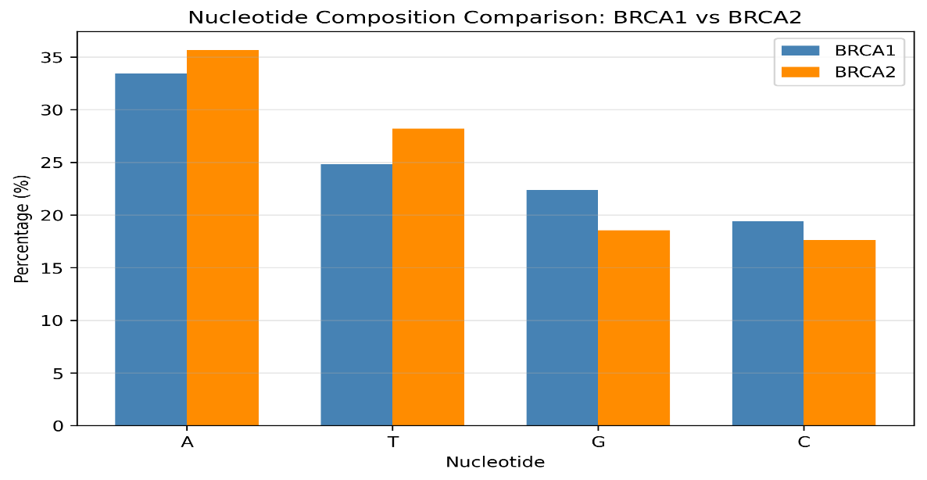

Figure1: Nucleotide composition comparison between BRCA1 and BRCA2.

Sliding -Window GC Content and GC/AT Skew

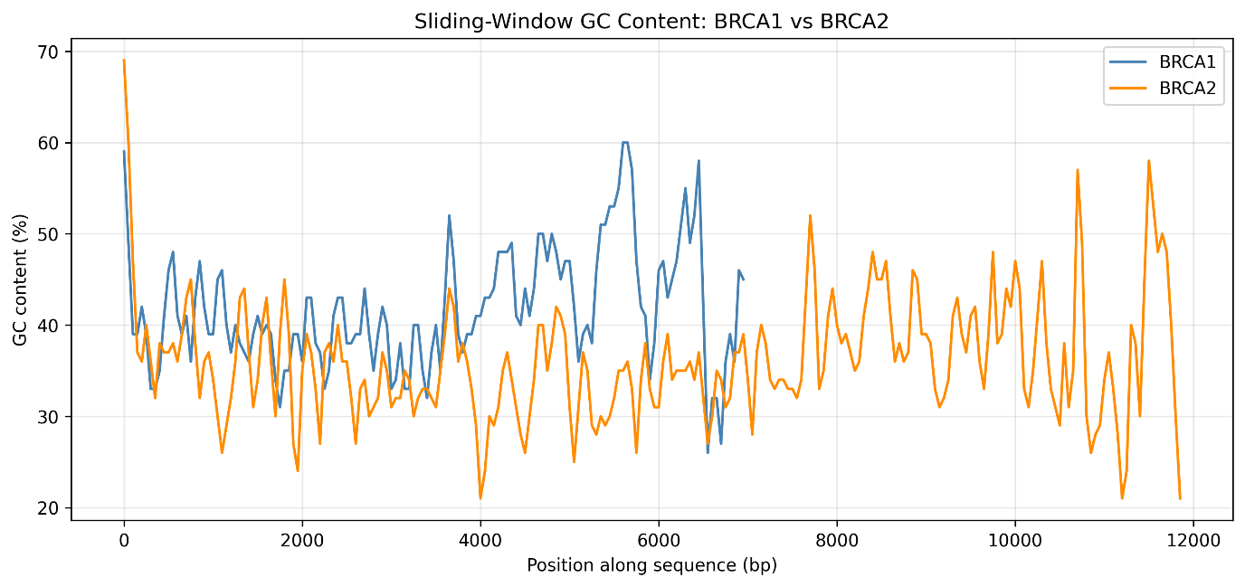
The GC content was plotted along the length of both genes in a sliding window approach as shown in Fig. 2. This difference does not occur in isolated areas, but is consistently higher GC content in BRCA1 than BRCA2. The corresponding GC skew profile is given in Figure 3, with both genes being positively skewed throughout, though more so in the case of BRCA1.

Figure 2: Sliding-Window GC content across BRCA1 and BRCA2

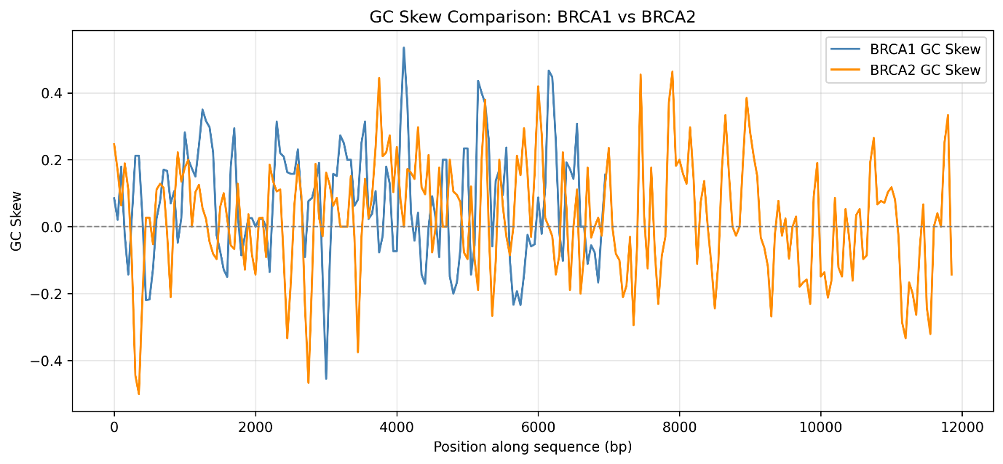
Figure 3: GC skew comparison between BRCA1 and BRCA2

Open Reading Frame Detection
Table 2 summarizes the total number of ORF counts and length statistics of the two genes. The individual ORFs are listed in Tables 3 and 4 for the BRCA1 and BRCA2 genes, respectively. The histogram of ORF lengths for both genes is presented in Figure 4. BRCA2 ORF 1 (10,257 bp) is much longer than BRCA1 ORF 1 (5,592 bp), which is congruent with the fact that BRCA2 codes for a larger protein as a whole.
Gene | No.of ORFs | Longest ORF (bp) | Shortest ORF (bp) | Mean ORF Length (bp)
BRCA1 | 12 | 5592 | 105 | 594.25
BRCA2 | 11 | 10257 | 108 | 1074
Table 2: Summary of ORFs identified in BRCA1 and BRCA2
2A.
2B.

Table (2A): Individual ORFs identified in BRCA1. (2B): Individual ORFs identified in BRCA2.
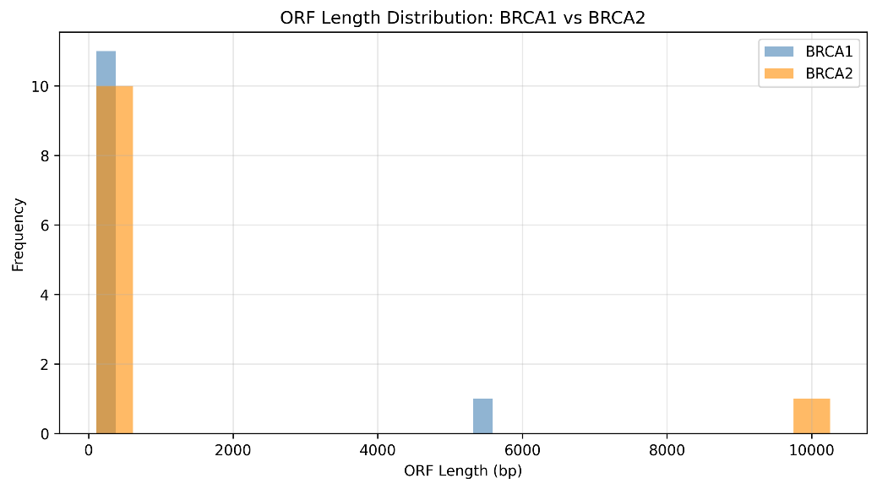

Figure 4: ORF Length distribution for BRCA1 and BRCA2

SNP Mutation Simulation

Simulated point mutations of each gene are classified as shown in Table 3. Out of 20 simulated substitutions, both genes had the same distribution of non-synonymous versus synonymous mutations, 18:2.
GENE | Non-synonymous | Synonymous
BRCA1 | 18 | 2
BRCA2 | 18 | 2

Table 3: Classification of simulated SNP mutations by type.

Statistical Testing

The difference in window-level GC content between BRCA1 and BRCA2 was found to be statistically significant using a Welch two-sample t-test with t = 8.05, df = 295.63, p = 2.11 × 10⁻¹⁴ (95% CI: 4.24–6.99). Here we present this comparison as a boxplot in Figure 5.
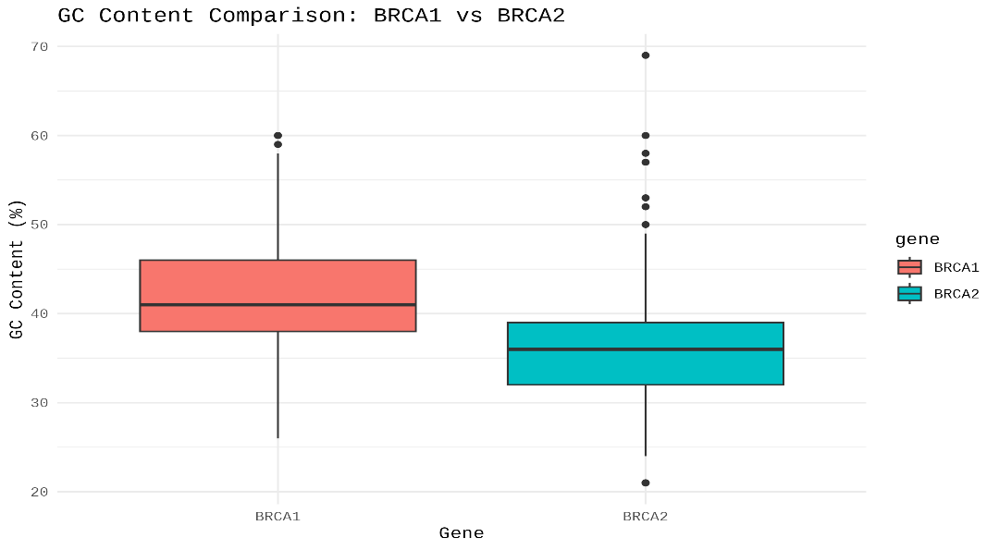

Figure 5: GC content distribution comparison between BRCA1 and BRCA2 (Welch two-sample t-test, p < 0.001).

DISCUSSION

Key Findings

The results of this study are consistent that both BRCA1 and BRCA2 are clinically linked to hereditary breast and ovarian cancer, but are very different at the sequence level. The overall GC content of BRCA1 was more than that of BRCA2 (41.77% vs. 36.18%. This difference was also not localised to specific parts of the sequence, but was visible in the sliding window plots. The difference was significant by the Welch two-sample t-test (p = 2.11 × 10⁻¹⁴), which is small compared to 5% significance, indicating that this is not a chance result. Further, ORF analysis showed that there are structural differences between the two genes: BRCA2 has one dominant ORF, which occupies most of its length, while the coding regions of BRCA1 are relatively spread out. Compared to the SNP simulation results, which showed the same ratio of changes (18 non-synonymous to 2 synonymous) for both genes, this 18:2 ratio was more likely due to a general property of the genetic code, and not to gene-specific properties.

Biological Interpretations

The difference in GC content between BRCA1 and BRCA2 observed is consistent with the genome organisation. The composition of nucleotides is not even distributed throughout the human genome but is affected by the location of the chromosomes, the local concentration of genes and the timing of their replication; so gene-dense, GC-rich regions are sometimes called isochores. BRCA1 and BRCA2 are located on two separate chromosomes, 17 and 13, respectively, and the different GC content may be found there is not a consequence of the genes themselves, but instead a consequence of the overall GC content of each gene site.
The ORF and SNP simulation results, when considered collectively, suggest the possibility of an association of coding architecture with mutational exposure. A large part of the BRCA2 gene (single long ORF (> 10,000 base pairs)) is translated into functional parts; a random mutational site has a relatively high probability of being in a translated part of the gene. The SNP simulation results with most mutations added at random, and mostly non-synonymous, support the clinical reasoning that a genetic test is warranted for the entire coding sequence of both BRCA1 and BRCA2 rather than a few known mutation hot spots.

Limitations

- Single reference transcripts: The analysis was performed on one reference transcript per gene and does not reflect the sequence variation in the population between individuals.
- Uniform mutation assumption: The SNP simulation is made for an equal chance of mutation for each position in a sequence, which may not be a true reflection of mutational bias as found in biology. Such a ratio is therefore expected to be synonymous to non-synonymous with the assumption of random substitution within the genetic code, and not the expected results of true mutations in the gene BRCA1 or BRCA2.
- Simplified ORF detection: The ORF detection method was based on the position of start and stop codons and does not use any information on splicing, regulatory context, or experimentally determined coding sequence annotations.
- Computational scope: Due to the above, the results of this study should be viewed as a computational, sequence-based comparison rather than a clinically tested analysis.

Future Directions

- Broader gene comparison: Using the same pipeline with a larger number of genes associated with DNA repair could be used to test whether the trend in compositional differences seen here is particular to BRCA1 and BRCA2, or indicative of a deeper trend for functionally related genes.
- Real population variant data: An enhanced biological relevance of the mutation analysis would be gained by using variant information from sources like ClinVar or gnomAD, instead of simulated random mutations.
- Structural integration: The correlation of ORF-level results to known protein functional types would provide an elaborate explanation of the relationship of sequence vs. functional level difference.

Conclusion

This study aimed to characterize and compare BRCA1 and BRCA2 at the sequence level, with a reproducible computational pipeline. The results were similar to all independent analyses: nucleotide composition, positioning skew (GC/AT) in the DNA, structure (ORF), and statistical testing all indicate that there was a clear distinction and it was significant between the two genes by GC content. The results from here are highly convincing that a lot of valuable and statistically reliable data about the characteristics of a gene sequence can be obtained without doing experimental lab work, but only using publicly available reference information and standard bioinformatics methods.

